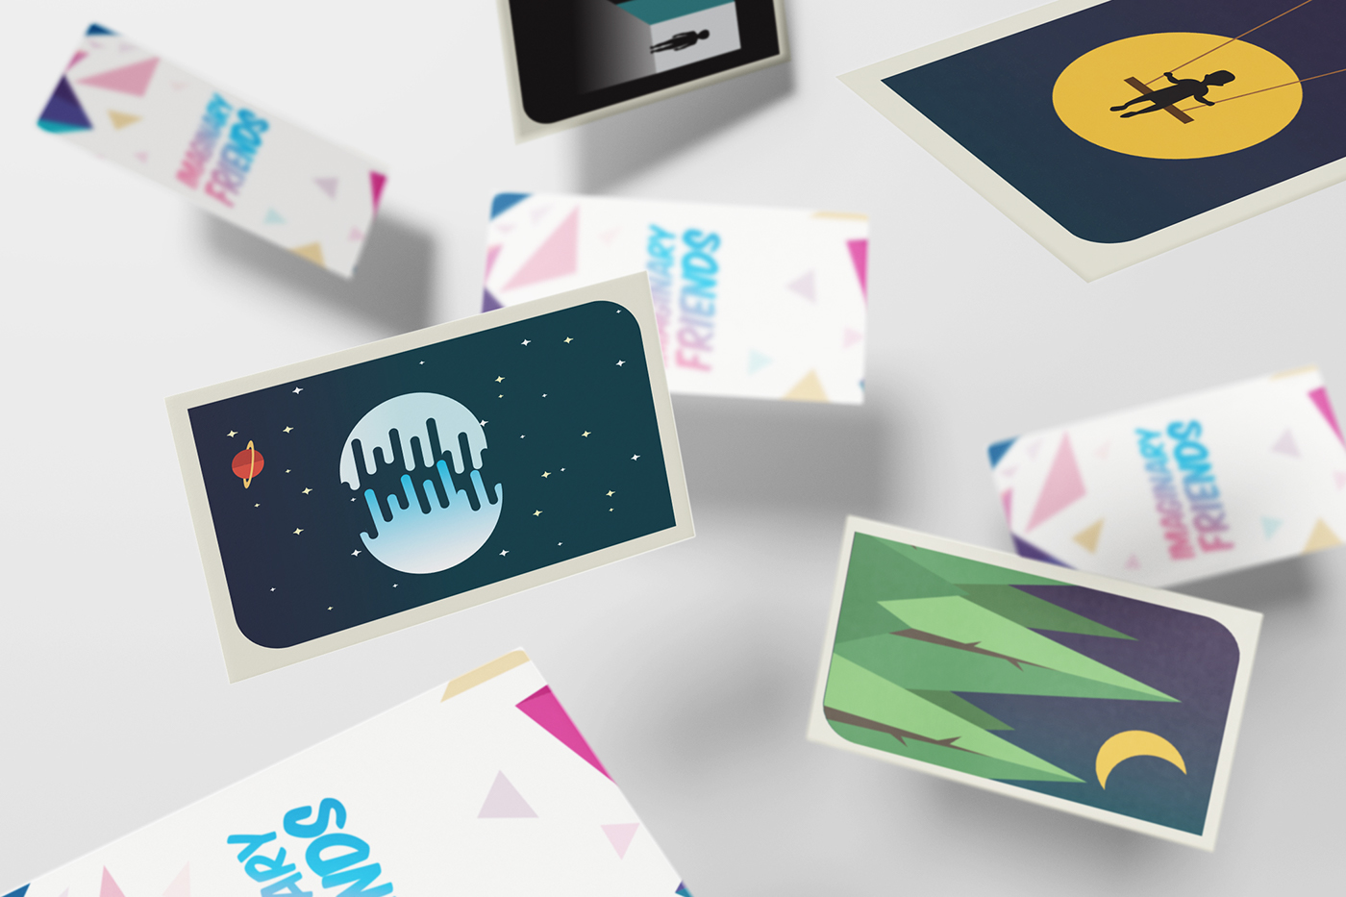

One fascinating aspect of graphic design is its ability to tell stories through imagery. A well-designed poster can evoke emotions and communicate complex ideas without a single word. Imagine a poster for a climate change documentary. It could use powerful imagery, like a melting glacier or a lone tree in a deforested landscape, to raise awareness and spark action. The message is clear and undeniable, proving that graphic design can be a powerful storytelling tool.

Another intriguing area of graphic design is its role in shaping brand identity. A company's logo, website design, and even packaging all contribute to its overall image. A well-crafted brand identity can build trust and recognition with consumers. Take, for example, the iconic Apple logo. The simple, bitten apple design is instantly recognizable and speaks to the brand's innovative and user-friendly products. Effective graphic design goes beyond aesthetics; it's a strategic tool for building successful brands.

Finally, graphic design is constantly evolving alongside technology. The rise of digital media has opened new avenues for designers. From interactive web design to motion graphics, designers are now creating dynamic and engaging experiences. This constant innovation keeps the field exciting and pushes the boundaries of what graphic design can achieve. The future holds even more possibilities, with applications in virtual reality and augmented reality waiting to be explored.